Architecture Proposal

for Mobile startup

by Nitin Magare

1. **E2E Diagram:**

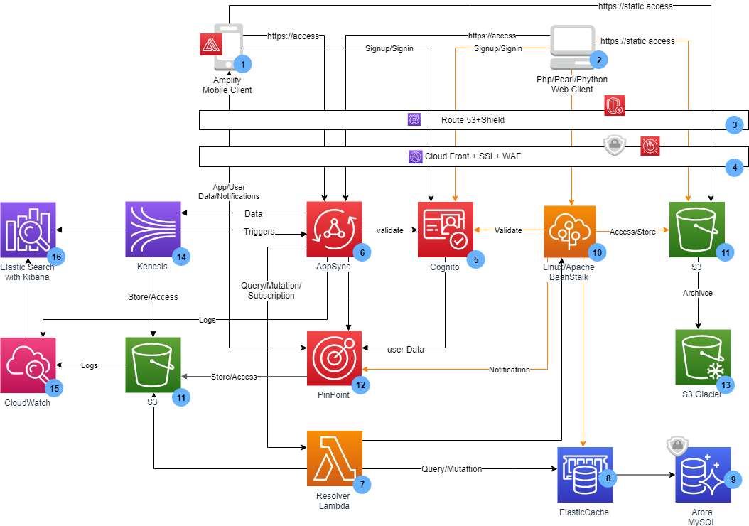

* 1. ***Component Details:***

|  |  |
| --- | --- |
| **No** | **Details** |
| 1 | Mobile app client which is recommended to be implemented using Amplify. Mobile Client shall have Pinpoint, and Congito SDK integrated to collect the application and user data for analytics. |
| 2 | Existing client application implemented using Php/Phython/Peral. |
| 3 | Route 53 DNS system shall be configured for the application. It is a recommendation to use *Shield* for enhanced **application security**. |
| 4 | Cloud Front for a quicker response to the dynamic and static content requested by mobile and web application globally, for **security of data in transit** It shall be configured with SSL. |
| 5 | Cognito with inbuilt support for MFA, IDP for mobile and web client registration. **To Manage user identities & sync user-specific data across multiple devices**. Its is where users can sign-up and sign-in. The logged-in user is validated and generated JWT token used for users session management. |
| 6 | AppSync shall be configured as a backend for the mobile application, AppSync supports GraphQL for faster exchange of data and subscription feature that allows **consumers & service providers to interact real-time** and offline also. Cloudwatch log shall be configured in AppSync to watch request and field-level data. Which can be then passed to ElasticSearch |
| 7 | Lambda works as resolver to access the multiple data sources like RDS, S3, including existing LAMP stack endpoint, incase required. |
| 8 | The Elastic Cache shall be used for higher performance and database layer. |
| 9 | Aurora is recommended to be used for **higher availability and durability**. Configured the Master node in one availability zone 1 and read replica is another availability zone 2 with auto synch ON. |
| 10 | Elastic BeansStalk shall be used to orchestrate the load balancer and autoscaling group. It shall help startups to start with **minimum infrastructure, Scaling to meet the demand, high availability** and **create self-healing infrastructure.** Elastic BeansStalk shall be configured to push the logs to S3. |
| 11 | S3 shall be used to serve the static content. It shall also be used to store the applications AMI’s, DB snapshots, applications logs, AWS infra logs, and archival data (configured with lifecycle policy to migrate to Glacier for archival) |
| 12 | Pinpoint shall work as customer engagnement and analytics platforms. Pinpoint shall be configured to collect the users and applications data, creation of users segments, sending notifications based on users segments. It shall also be configured to export the data to kensis stream for realtime analytics. |
| 13 | S3 Glacier shall be used for storage and archival of the data, e.g. **inactive objects greater than 6 months.** |
| 14 | Kensis shall be used incase if any reatime analytics has to be done. Kensis shall also identify the list of inactive users and can export that to S3 which can be then archived S3 glarcier by S3 lifecycle policy |
| 15 | Cloudwatch configured to analyise logs and monitor events. |
| 16 | ElasticSearch search, analyse, and visualise AWS Kensis AppSync logs. Use ElasticSearch services to identify performance bottlenecks and a root cause of operational issues. It shall be used to identify resolvers with the maximum latency and errors. Also, [Kibana](https://aws.amazon.com/elasticsearch-service/the-elk-stack/kibana/) dashboard shall be used for visualisations, continuous monitoring the performance and health. |

1. **Traceability Matrices**

|  |  |  |
| --- | --- | --- |
| **No** | **Business Requirement** | **Mitigation** |
| 1 | Provide the infrastructure for existing LAMP stack comprising of open-source software. | This shall be achieved by using Elastic Beanstalk and Aurora.   * Configure Elastic Beanstalk with **L**inux EC2 Instance with **A**pache server. * Configure Aurora with **M**ySql * Application web Layer shall be implemented with **P**hython/**P**earl/**P**hp. |
| 2 | Launch a new mobile application that allows consumers & service providers to interact real-time | It is recommended to used Amplify to implement the mobile client. It has inbuilt support for AppSync and GraphQL which shall allow consumers & service providers to interact real-time. Amplify also has inbuilt UI components for user |
| 3 |  |  |
| 4 |  |  |
| 5 |  |  |
| 6 |  |  |
| 7 |  |  |
| 8 |  |  |
| 9 |  |  |
| 10 |  |  |
| 11 |  |  |
| 12 |  |  |
| 13 |  |  |
| 14 |  |  |
| 15 |  |  |
| 16 |  |  |
| 17 |  |  |
| 18 |  |  |

1. **Assumptions**

Targetting Right Customers (segmentation)

Monitoring Customers events

performanace and costing consideration

* remove inaccessible users.
* Archive inactive user data.
* Segmentation of customers

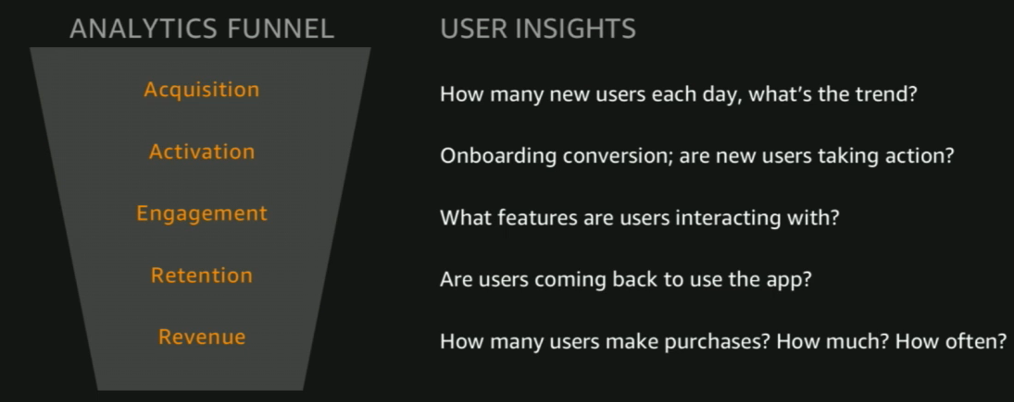

Design Principles

* Implement strong identity protection
* Enable Traceability
* Apply Security at all layers
* Automate Security best practices
* Protect data in transit and rest
* Keep people away from data
* Prepare for security events.